**CIS-350  
Infrastructure Technologies**

**Lab 2 Report – Fall 2019**

**Student Name**: **Mohammed Al Madhi**

**You must use this template to hand in Lab 2 Report.**

1. Insert *Lab2_Tree* file from p. 8 of the Lab 2 instructions into the space provided or use the *Alt-PrtScr* keys to capture the screen output (window) from command *TYPE Lab2_Tree* on p. 8 and paste that window here.

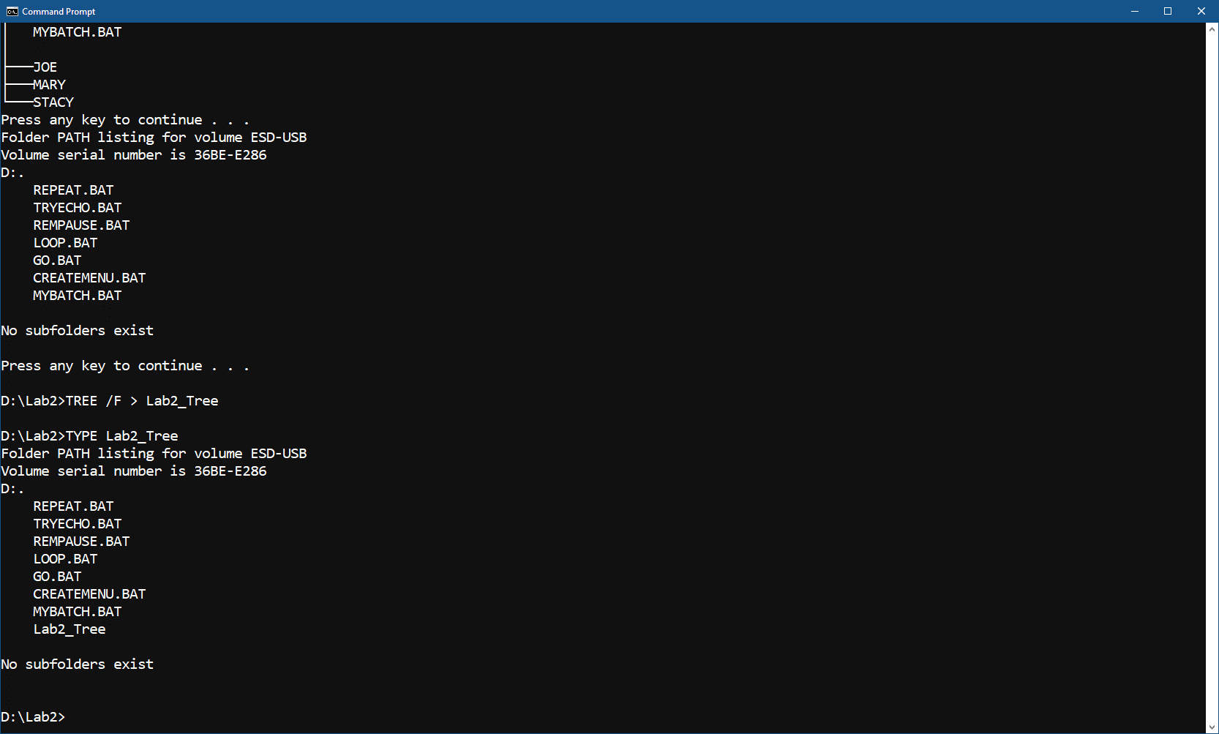

1. Assume that the system prompt displays "C:\>", i.e., your current directory and current drive are the root directory and C drive, respectively. Write a batch file below that will include commands to:
2. prevent all commands from displaying on the screen. Also, disable command ECHO OFF from displaying.

ECHO OFF

1. display the following message "My first script file"

REM My first script file

1. display the directory hierarchy/structure of the C disk (Do not use DIR)

tree

1. display the directory hierarchy/structure of the C disk with all files (Do not use DIR)

tree /f

1. create subdirectory named *LETTERS* in the root directory

mkdir LETTERS

1. erase subdirectory *BOOKS* from the root directory

rmdir BOOKS

1. copy file *loop.bat* to directory *LETTERS*

COPY loop.dat C:\LETTERS

1. pause the screen

PAUSE

1. use the piping operation to display the sorted directory and display it one screen at a time (prevent the screen from scrolling off). Need to use two pipes.

DIR | SORT | MORE

1. sort data in the descending order coming from file *Names1* and route the output to file *Names1_Sorted*

SORT /R < Names1 > Names1_Sorted

The batch file, commands (a) through (j):

ECHO OFF

REM My first script file

tree

tree /f

mkdir LETTERS

rmdir BOOKS

COPY loop.dat C:\LETTERS

PAUSE

DIR | SORT | MORE

SORT < Names1 > Names1_Sorted

1. Describe step by step what a file named MYSCRIPT does.

@ECHO OFF

//When ECHO is off it is not going to display anything in the CMD, if on it will display in CMD

REM STARTING SCRIPT FILE

// REM command is sending the message to display to the screen it is like a comment.

TREE /F

// will list the files within the directory/subdirectory that we are currently in

PAUSE

// PAUSE will pause the script and wait for a user to initiate the script again.

DIR

//Shows the DIRectory of the drive we are currently in.

PAUSE

//It will pause the script again and waits for the user to initiate it again.

MD HANK TOM LISA

//the MD commands means Make Directory for each HANK, TOM and LISA(each will have their own folder)

TREE /F

//shows the files and subdirectories within the current directory.

PAUSE

//It will pause the script again and waits for the user to initiate it again.

COPY *.BAT D:\LAB2\LISA

//Copying all the .bat files to the directory path D:\LAB2\LISA

TREE /F

//// will list the files within the directory/subdirectory that we are currently in

TREE

display the directory hierarchy/structure of the Current disk

PAUSE

// PAUSE will pause the script and wait for a user to initiate the script again

CD LISA

Creates Dirctory Named LISA

ERASE *.BAT

Erases all .bat files

PAUSE

//It will pause the script again and waits for the user to initiate it again.

CD ..

Sends us back one directory path.

TREE /F

shows the list of files and subdirectories

PAUSE

//It will pause the script again and waits for the user to initiate it again.

RD HANK TOM LISA

Removes Directory HANK, TOM, LISA

TREE /F

then shows the new list of files and subdirectories

PAUSE

//It will pause the script again and waits for the user to initiate it again.

REM CLOSING SCRIPT FILE

Displays the text closing script file on screen

Assumptions: The prompt D:\LAB2> is displayed. D is the current drive and LAB2 is the current directory just below "\" (the root directory).

|  |  |
| --- | --- |
| **Command** | **Description (Fill in)** |
| **@ECHO OFF** | Stops command from appearing on screen |
| **REM STARTING SCRIPT FILE** | display the following message “STARTING SCRIPT FILE” |
| **TREE /F** | display the directory hierarchy/structure of the C disk with all files |
| **PAUSE** | will pause the script and wait for a user to initiate the script |
| **DIR** | DIR displays the entire directory the user is in |
| **PAUSE** | Pause stops the file again. |
| **MD HANK TOM LISA** | Makes directory HANK, TOM and LISA |
| **TREE /F** | display the directory hierarchy/structure of the C disk with all files again including the ones we created above. |
| **PAUSE** | will pause the script and wait for a user to initiate the script again. |
| **COPY *.BAT D:\LAB2\LISA** | Copies all .BAT files to the LISA subdirectory. |
| **TREE /F** | Displays the directory hierarchy with all files in the current path. |
| **TREE** | display the directory hierarchy/structure of the Current path |
| **PAUSE** | Pauses the script and waits for user to press a key |
| **CD LISA** | Moves the focus to subdirectory lisa |
| **ERASE *.BAT** | Erases all .bat files |
| **PAUSE** | Pauses the script and waits for user to press a key |
| **CD ..** | Returns focus to the parent directory of LAB2 |
| **TREE /F** | Displays the directory hierarchy with all files in the current path again. |
| **PAUSE** | Pauses the script and waits for user to press a key |
| **RD HANK TOM LISA** | Removes directory HANK, TOM and LISA |
| **TREE /F** | Displays the directory hierarchy with all files again. |
| **PAUSE** | Pauses the script and waits for user to press a key |
| **REM CLOSING SCRIPT FILE** | Displays text “CLOSING SCRIPT FILE” |

1. Optional. Briefly describe any issues with the lab. Point me to the specific pages and suggest changes. Thanks.